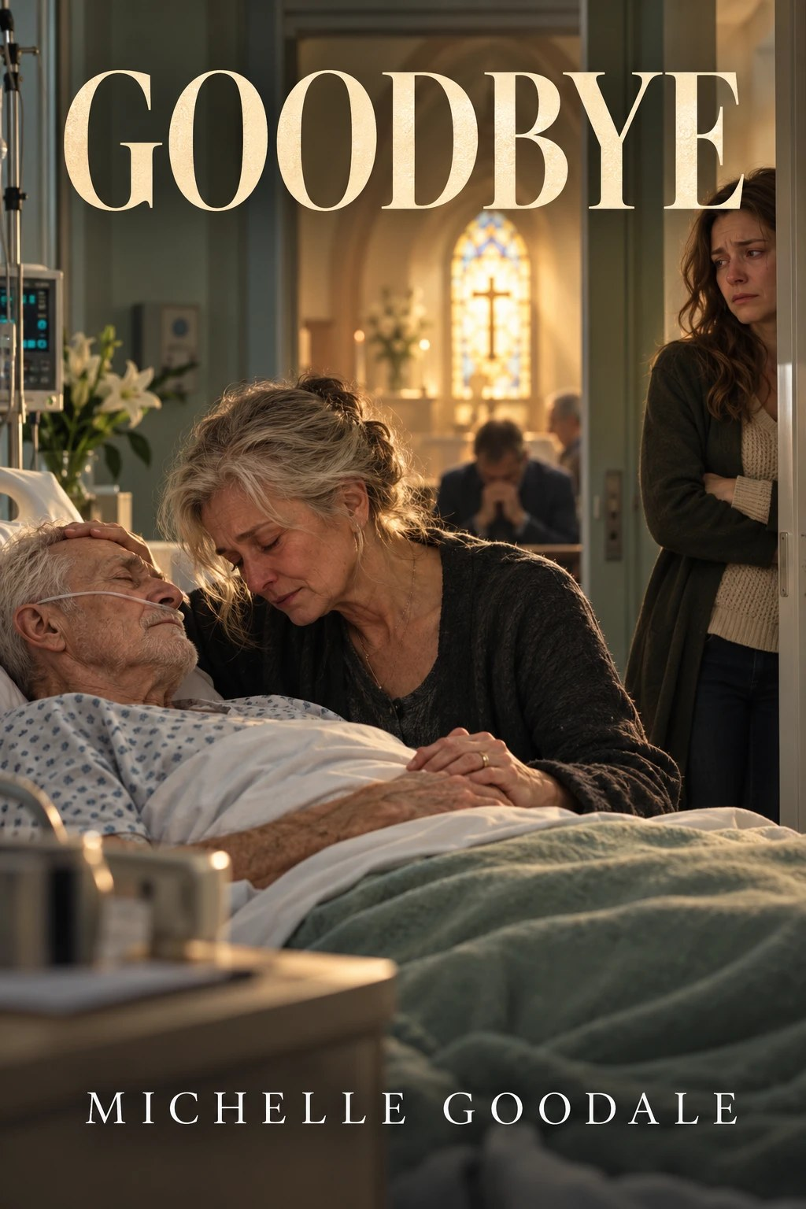

Goodbye
by Michelle Goodale
The hospital room was quiet except for the sound of the oxygen as it was pumped into the man laying on the bed gasping for air. He didn’t seem like he was anything more than the shell of what used to be a man, his skin clung to his bones showing the years of slowly wasting away. His eyes closed, his body lurching as he tries to take in his next breath.
The other occupants of the room are trying hard to keep control of their emotions, each one trying to be strong for the rest. Helen held the mans hand. Her fingers playing lightly on the smooth round wedding band, which is slightly oblong because of a long ago accident. When the man had almost crushed his finger in a car door. While with her right hand she rubbed the top of the mans head where his gray hair had ceased to grow long before she had met him. Her brown eyes red and puffy from the stress she had been going through and the long night she had spent awake with him. She looked exhausted as if she would give up when he did, it seemed strange to see this woman who could make a military drill Sargent stand down from an argument, this vulnerable.
In a green leather easy chair sits a young man dressed in black, his hair scruffy from a year of letting it grow out. His body like that of the Pillsbury dough boy, hunched over so his head could rest on his clasped hands, and his elbows rested on the arms of the chair. His dark brown eyes harsh and brooding.
In the short hallway leading from the door of the room to the room itself a young woman stands shifting her weight from her left leg to her right nervous. She remembered this scene well from her younger days when her mother had died in the same fashion. Suddenly she folder her arms in front of herself trying to keep from wringing her hands raw. She looked like a small child in with the big kids, not really belonging but not out of place. Her breathing becoming shallow and far between as she fell into a trance watching the man in front of her. Jess could feel herself suffocating, as if there were no more air left in the room, so she did an about face and left the room unnoticed. It scared her that she would be losing yet another family member to the big C. No one in the family ever used the word cancer anymore, they all knew the disease too well not to address it by it’s nickname.
The hallway seemed to have more air and room as she looked around she walked down, it seemed bigger than it was because of the reflecting white light from the shiny tile floor and smooth pastel green walls. The hallway was empty except for the occasional nurse passing by dutifully from patient to patient. Calmly Jess stopped when she reached an intersection of hallways. Ahead lay more rooms she guessed filled with terminally ill patients. To her left the metallic doors of the elevator above it the lights told the story of where it was. To her right a huge dark oak wood door loomed like the door to the Vatican the right side was the only one open which seemed to call to her invitingly. Curious about what lay beyond Jess moved toward it, checking her past trail every so often as if expecting someone to jump out and yell at her. When she arrived at the opening of the door she could see the two rows of church pews of a lighter oak color and the crosses that provided decoration on the end of every other pew was an even lighter oak color. Her eyes drew to the stained glass windows on the walls of the small church and felt her gut tingle as if she didn’t belong there. The stained glass windows she could tell depicted important scenes from Jesus Christ’s life. Jess’s eyes found the front of the church and she marveled at the Madonna and the huge brass colored crucifix that loomed in reminder of Christ’s death. She glanced again around the room and found the stain glass window of Christ’s ascension in to heaven and began to pray in her own way.
Please God, she begged in her mind, Please stop his pain and the pain of those who love him. Make it quick so it won’t hurt anyone else.
Quietly she glanced down at her feet then turned to leave as she brought her head up to see where she was going she found feet, her eyes moved higher to reveal black jeans. Higher still she could see that it was her cousin Mark, the dying man’s grandson. The boys black hair and clothing provided for high contrast and gave him a slight glow from all the reflected light behind him. He looked about ready to crack as he looked at Jess with his brown puffy red eyes. The look was all Jess needed as she felt herself about ready to cry she clinched her jaw tight to hold back the tears, as she once again looked back at her feet sad, not wanting to meet his eyes. Jess walked back down the corridor until she reached a small waiting area. She sat down the sunlight from outside came in just like the warm summer day it was. Mark joined her in the area. It wasn’t long before Renee, and Molly joined them from the hospital room. The four cousins sat and talked, about anything other than what was staring them straight in the face.
Only fifteen minutes had passed when Patty had come out of the room, her face was puffy and red from crying. “It’s almost over,” she announced quietly, “If you want to be there.”
The four cousins followed her back into the room. Jess took up her previous spot in the hallway. Fists shoved deep into her pockets, her body tense trying not show the tears, trying not to let them out. The man on the bed sucked at the air as if he was breathing through plastic. The distance between the breaths got longer and longer. Until, it seemed that it was over. “It’s over, he’s gone,” Jane announced quietly and hugged Renee.
The man sucked in another breath after what seemed to be an eternity and then went limp on the bed. The breath had been a last ditch effort for the bodies survival. Jess didn’t even notice when Jane had moved up beside her. Her Aunt went to put an arm around her shoulder but instead of accepting the comfort. Jess jerked away suddenly trying to avoid the contact that would make her loose the last bit of control she had over her emotions.
“You can’t do that, you can’t pull away from everybody.”
Jess didn’t want to hear it. She just didn’t want to be touched, having been willing herself not to shed a tear over this man. This man that had always seemed to look at her as less than anything adequate.
Helen ran a hand over the mans face and then kissed his lips. “He’s still warm if you want to say good bye.” She was hurting and you could see the tears but she showed the strength of someone who had been through war. Everyone took their turn to say goodbye to the man. But Jess just stood there quiet, she stayed as they all left one by one. Each of them quietly.
When Jess was alone in the room with him she looked at him and couldn’t hold back the tears anymore. Angry she looked at him and wanted to say so much to the man but couldn’t get over the idea of the body. Knowing that it wasn’t the man that was there any more . The man she had tried so hard to please. So hard to prove herself too. It was over now. There was nothing more that could be done. Quietly she walked out of the room, trying to regain control over her emotions as she went.
writingsonline.com
