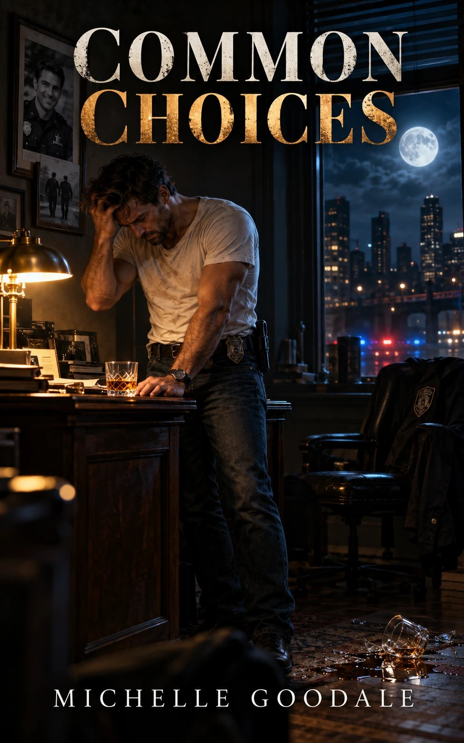

Common Choices
by Michelle Goodale
Common Choices
Note: Originally written in 1994 as part of a Health Class assignment, in which we were to describe an alcoholic. This was my attempt at fulfilling that assignment. I know it’s cheesy. This version was polished up some from the original.
Amber liquid swirled in the whiskey glass at the command of a once gentle hand, which now gripped it with anger. A well-muscled man hunched over, his forearms as they rested on the edge of the large oak desk, stared at the swirling fluid. The harsh light from the desk lamp cast well defined shadows of the glass and the mans arms onto the dark satin finish. His brooding brown eyes grasping closed suddenly in a torrent of trying to shut out the events of the past. Horrid events of a time needing to be forgotten, events that now haunted him after so many months. Frustrated the man pushed himself back and out of the soft comfortable rolling desk chair, sending it back a few paces.
His eyes whirred around with his body to stare at the pictures on the wall behind him and to the left of the window. The pictures, all that was left of him and his partner, documenting the happy times they had spent together patrolling the streets. Tom Marks. He’d been a great officer always ready for fun and a good joke.
“Always keep your chin up and your eyes open, Cardigan.”
The words echoed in his mind like a ship lost at sea, eyes open the key to life, Cardigan stared out the window into the dark night. The full moon hung over him, as his mind was racked with pictures of the routine stop on Santa Monica Boulevard, four months ago. Nothing too suspicious, just a speeder. Tom casually got out as he reminded Jake of a drill sergeant about to pull a fast one on an unsuspecting cadet. It made Jake smile knowing Tom’s soft personality that made women fall all over him. A fact that would have made Jake jealous if he hadn’t been married to Marie.
Staying in the car Jake watched through the windshield while keeping an ear open for the radio. His eyes scanned the plate ESYRDER, one of those personalized plates that told way too much about the owner than a license plate should. Jake’s eyes went to the computer screen before him. He scanned the list of unpaid speeding tickets on the guys driving record.
“An easy rider, no doubt,” Jake scoffed to himself as he looked at his watch. 10:47 p.m., almost time for lunch. His stomach growled-BANG! SREEECH! The sound broke his thoughts, jerking his head up he could see. . . Tom standing, stunned, dazed as if in a dream world while the car Tom once stood beside disappeared down the street in a whirl of burning rubber.
Grabbing the radio, “Officer down, Santa Monica Boulevard and Dodgeson, Officer down!”
There was no time for anything more as he jumped from the patrol car and raced time to his partner, who had finally teetered to the ground and was laying in a pool of blood. A gouging bullet hole in the center of his forehead. Bone, brain matter and blood oozing out the exploded back of Tom’s head as if all boundaries of the world had to be crossed to see the light. Tom’s green eyes stared up into the night sky; void of expression, the light of the full moon reflecting in them the horror of what had happened only seconds ago.
“NO,” Jake demanded as he brought himself back to the present trying to forget the horrifying night. Quietly he stared out the window seeing that same full moon he had seen in Tom’s eyes the night. . . The night, Stop! He clenched his eyes closed for a second regaining his thoughts. He took another drink from the glass letting the whiskey’s heat numb his heart and mind from the events he so wanted to forget.
In the doorway Marie stood, clad in a bath robe that masked her lithe figure her heart sunk at the sight of the man in front of her. His face wearing two days’ growth of prickly stubble. His soft brown eyes brooding and full of guilt that he tried to rid himself of with the bottle of whiskey that sat like a guard on the edge of the desk.
She began to wonder what had happened to the man that she had married six years ago, where the spark in his eyes had gone, the large smile that was as contagious as a cold. The formal man who was just too laid back to be formal. The old brown leather jacket he wore that looked as though he had just bought it, all of that was gone. The leather jacket laid on the floor like a dirty rag, his white t-shirt and blue jeans wrinkled and soiled on Jake’s large frame as if he had spent too many nights sleeping in the office. The smile now a scowl that burned into the very heart of the man, and his eyes angry and dull.
Marie just wished she could say something, anything to help, standing quietly in the doorway she watched him finish off his glass, then swagger to the desk, he poured the last two gulps into the glass. Angry, Jake, threw the bottle against the wall narrowly missing Marie, as it burst into a million shards, causing Marie to jump.
He caught sight of her and his eyes shot through hers like daggers, while he himself became sarcastic and mean. Angry he tossed his glass at the wall, like a major leaguer throwing a fast ball, causing the glass to shatter against the wall on his left. The two gulps draining down the wall to form a dark wet puddle on the floor. Afraid that if she confronted him any more he would loose all control he demanded her to leave.
She stood her ground, the cotton robe hanging loosely on her body, her long blond hair resting on her shoulders and cascading down her back. And those defiant blue eyes, the reason he had married her in the first place. She always stuck around when things seemed at their worst, tearing down his facade of portrayed happiness and digging deep into his heart. I can’t deal with this now he thought frustrated. Running his fingers sharply through his short brown hair.
“Jake, your turning into a drunk.”
“Turning honey I’m already there.” he said sarcasm dripping off his words like syrup.
“We can discuss your problem-“, she started to say and stopped suddenly.
As, Jake, bounded across the room and then the sickening sound of flesh striking flesh resounded through the small space. Jake’s eyes shot up to hers, the pain that he inflicted evident in her eyes as she held her hand to her cheek. Afraid he’d do it again, he pushed her out and slammed the door in her face then quietly he fell against the wall as his eyes grew red and puffy, tears fell carefully down his face, he cried as he slid himself down the wall and hugged his knees. Then he could feel a warm embrace. Then Marie’s voice trying to soothe him as if he had just been beaten up by the schoolyard bully, which didn’t seem to matter to him at the moment. He was surprised that Marie could still love him even after what he had done. Slowly he lifted his eyes to look just above Marie’s arm, he could see the broken glass and the whiskey he had depended upon to stop the pain soaking the carpet. Then he wondered what he would ever do if he lost Marie. As the whiskey was of no consequence.
Mental Note on this story, I used to like to write reality based fiction and most of it usually involved cops or animals, or even both. I honestly can’t remember what grade I received on the assignment anymore. But I’ve had some compliments on my ability to write description. Some people have asked for more to the story. But like in
Stand by Me
That’s it, there is no more.
writingsonline.com
